**Crisis and Transition: How the Russia - Ukraine War Reshaped EU’s Energy Landscape**

**Group 1**

**Nick Arredondo**

**Shreya Mukhopadhyay**

**Tapiwa Zvomuya**

**Zikai Qian**

**CHBE 548: Fall 2025**

**Date: 10.02.2025**



**Table of Contents**

1. **Table of Contents 1**
2. **Abstract 2**
3. **Abbreviations 3**
4. **List of Figures 4**
5. **Introduction 5**
6. **EU’s Immediate Crisis Response 11**
7. **Trade-Offs in Energy Policy 16**
8. **Climate Policy & Global Transition 21**
9. **References 26**

**Abstract**

The Russian invasion of Ukraine in 2022 triggered the most severe energy crisis in Europe since the oil shocks of the 1970s, exposing the European Union’s (EU) overreliance on Russian natural gas as a profound geopolitical vulnerability. This paper critically examines the EU’s immediate crisis responses, including diversification of liquefied natural gas (LNG) supplies, emergency reactivation of fossil assets, gas storage mandates, and the REPowerEU strategy, while interrogating the structural trade-offs these measures produced. Although short-term actions successfully prevented systemic collapse, they simultaneously reinforced long-term risks of fossil fuel lock-in, uneven burden-sharing between Western and Eastern member states, and renewed exposure to external supply chains for clean technologies. The EU’s pre-war paradigm, optimized for efficiency but not resilience, created path dependencies that magnified the crisis and constrained the flexibility of response.

The subsequent pivot to renewables and efficiency reframed decarbonization as a matter of energy security, yet paradoxically relied on transitional fossil investments that complicate climate trajectories. From a critical perspective, the Ukraine war functions as a stress test for global climate governance, revealing the fragility of energy transitions when confronted with geopolitical shocks, the limits of technological optimism in decarbonization strategies, and the persistent equity divide between advanced and developing economies. Ultimately, the EU’s energy shock should be understood not as a temporary disruption but as a defining inflection point. The crisis underscores that sustainable energy transitions demand not only technological acceleration but also institutional resilience, systemic redundancy, and political willingness to reconcile the conflicting imperatives of security, affordability, and climate responsibility.

**Abbreviations**

**EU - European Union**

**BCM - Billion Cubic Meters**

**LNG - Liquefied Natural Gas**

**FSRU - Floating Storage and Regasification Units**

**RRF - Recovery & Resiliency Facility**

**CCUS - Carbon Capture, Utilization, and Storage**

## 

**List of Figures**

## Fig 1.1: EU’s dependence on Russian natural gas in 2020 6

Fig 1.2: European cross-border transmission capacities and import points 7

Fig 1.3: EU gas import capacity and supply by source (bcm) in 2021 9

Fig 2.1: EU Energy Supply Measures 12

Fig 2.2: Decline of Russian gas imports under REPowerEU, 2022–2025 14

Fig 2.3: EU gas storage targets vs. actual fill rates, 2021–2023 15

Fig 2.4 EU natural gas consumption reduction, 2021–2023 (monthly % change) 16

Fig 3.1 Increase in Inflation due to Energy Prices in EU countries 19

## 

## 

## **Introduction**

## The Russian invasion of Ukraine in February 2022 disrupted Europe’s natural gas markets and triggered the most severe energy crisis in the EU since the oil shocks of the 1970s. The crisis struck at the center of the European Union’s natural gas system, and as Russia was not just one of several suppliers but the dominant oil & gas provider prior to the war, delivering more than 40 percent (Di Bella et al. 2024) of the EU’s total natural gas imports by 2020. Furthermore, the EU’s dependence on Russia was the overall result of decades of pipeline network development around Russian supply, policy decisions, and geopolitical assumptions that tied European prosperity and industrial competitiveness to Russian pipeline gas. Thus, understanding the depth and structure of the EU’s reliance on Russia is critical for assessing the immediate energy shock of 2022 and the long-term implications for Europe’s decarbonization*1* strategy. From a systems perspective, the EU entered the war with a gas network optimized for cost efficiency but not resilience, which further made it vulnerable to both supply disruptions and geopolitical coercion (Di Bella et al. 2024).

## **1.1 Russian Gas Dominance in the European Energy Import**

## Russian gas exports to the EU totaled approximately 155 billion cubic meters (bcm) by 2020 (Di Bella et al. 2024), accounting for around two-fifths of the EU's total gas consumption. These gas volumes were utilized in residential heating and power generation, and also served as an indispensable energy source for European industries, including those in the chemicals, steel, aluminum, and fertilizers sectors.

[1]

## 

## *Fig 1.1: EU’s dependence on Russian natural gas in 2020*

## Next, the physical backbone of the EU's gas network consists of four major pipeline systems. The Nord Stream 1 pipeline, a direct undersea link between Russia and Germany, delivered over 55 bcm (Ag, n.d.) annually at full capacity. The Yamal-Europe pipeline, which transits through Belarus and Poland, added a further 33 bcm (“Russia’s Gas Transit Through Ukraine: End of an Era?” 2025). Meanwhile, the Brotherhood and Soyuz pipelines, which run through Ukraine, historically carried over 100 bcm annually before declining in importance due to transit disputes in the 2010s. Together, these assets created a dense web of supply lines that enabled Russia to meet European demand at scale and with limited competition. From an engineering standpoint, these pipelines represented highly capital-intensive, long-lived infrastructure with designed lifetimes of 30 to 50 years. Hence, their presence also created a form of infrastructure lock or path dependency, and downstream consumers and industries were effectively locked into relying on these flows as alternative supply chains were underdeveloped.

**1.3 Structural Vulnerabilities in the EU Gas System**

Europe’s gas system before 2022 exhibited three significant systemic vulnerabilities – geographic concentration, infrastructural asymmetry, and policy-related reinforcement that amplified the shock of losing Russian gas supply.

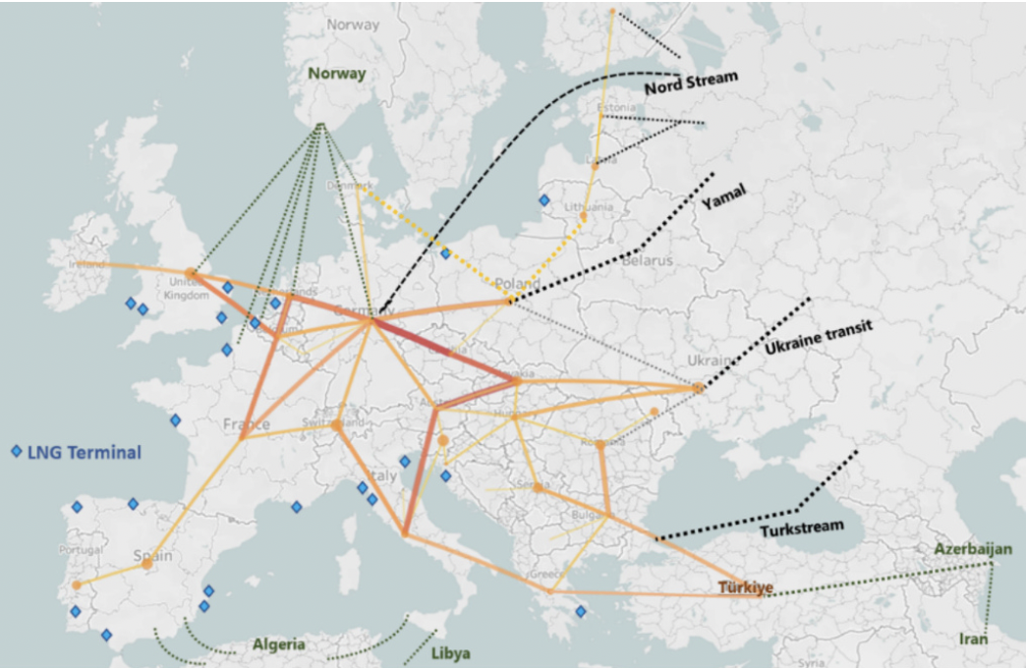

*Fig 1.2: European cross-border transmission capacities and import points; Source: (Di Bella et al. 2024)2*

*[2]*

**Geographic concentration** of energy dependence was most acute in Germany, the EU’s largest economy. German industry, particularly the chemicals and heavy manufacturing sectors, [3]depended heavily on uninterrupted flows of cheap Russian gas. Furthermore, countries in Central and Eastern Europe, such as Hungary, Slovakia, and the Czech Republic, were even more exposed, importing nearly all of their natural gas from Russia. By contrast, Western European states such as Spain and Portugal were more insulated because they had developed alternative supply routes via liquefied natural gas (LNG).

**Infrastructure asymmetry** was another critical factor that made the EU vulnerable, as the energy dependence varied across countries. While Western Europe had invested heavily in LNG regasification capacity, Spain alone accounted for over one-third of the EU’s LNG import capacity before the war. Eastern and Central Europe, in contrast, lacked such infrastructure. The absence of sufficient interconnectors further meant that LNG arriving at ports in Spain or France could not be easily transported to eastern, landlocked countries. Thus, it created a structurally asymmetric system where abundant energy flexibility in the western EU coexisted with rigid dependence in the east.

Finally, **policy and market frameworks** also reinforced the EU’s historical energy dependence3. Natural gas was widely regarded as a “transition fuel” that would help Europe reduce its reliance on fossil fuels while scaling up renewable energy sources. In practice, this policy orientation also increased reliance on Russian imports. German policymakers, for example, accelerated their coal phase-out plans while investing in long-term pipeline capacity, exemplified by the Nord Stream 2 project. This €10 billion pipeline, completed but never commissioned, was intended to double the direct flow of Russian gas to Germany, further embedding its dependency within the EU energy system.

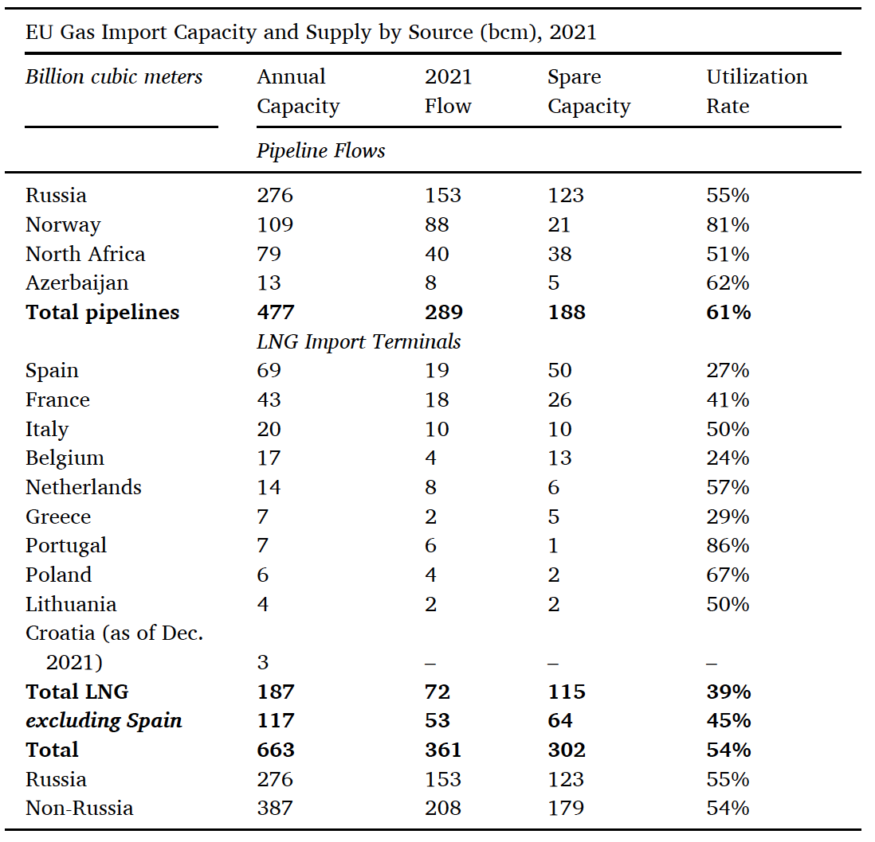

*Fig 1.3: EU gas import capacity and supply by source (bcm) in 2021*

*Source: (Di Bella et al. 2024)*

**1.4 Beyond Economics: The Geopolitical Dimension of Gas Dependence**

Russian gas was attractive not only because of its physical availability but also due to its cost-effectiveness. Pipeline gas typically arrived at a lower marginal cost than LNG, which involved stages of liquefaction, transport, and regasification. For many EU member states, particularly Germany and Italy, the affordability underpinned industrial competitiveness. However, energy security is not solely an economic concept; it is also a geopolitical one. By importing such a high proportion of gas from a single supplier, the EU reduced its energy resilience and provided strategic leverage to Moscow. The 2014 annexation of Crimea had already illustrated Russia’s willingness to deploy energy as a political instrument. However, instead of reducing energy dependence, several member states increased their reliance on it over the years. The decision to move forward with Nord Stream 2 exemplifies this flawed logic. It signaled to Russia to continue leveraging its position as Europe would still prioritize affordability and climate goals over diversification and resilience.

From a risk assessment perspective, the EU effectively concentrated supply risks rather than diversifying them. Such a configuration is undesirable in any engineered system, whether it is a chemical process plant or an energy supply chain, because a single-point failure (in this case, geopolitical conflict) can trigger cascading impacts across the entire system.

**1.5 The Pre-War Energy Paradigm**

Before 2022, the EU’s energy paradigm rested on an implicit bargain that the affordable Russian gas would provide economic competitiveness and a smooth transition to a renewable future. Policymakers assumed that natural gas would support the phase-out of coal while backing up variable renewables like wind and solar. This framework treated supply security as a solved problem and climate ambition as the primary focus. The Ukraine war disrupted this paradigm by showcasing that energy security and sustainability are interconnected. Gas dependence on Russia left Europe vulnerable to supply shocks, and the infrastructure built to deliver stability became a liability. From a chemical engineering perspective, the system was optimized for steady-state operation but lacked robustness in emergencies, a classic trade-off between efficiency and resilience.

**1.6 Analytical Framing for the Crisis Response**

The massive scale of Europe’s reliance on Russian gas explains why the Ukraine war produced a profound energy shock. The dependence was significant (>40% of imports) (Di Bella et al. 2024) and institutionally embedded through historical contracts and substantial infrastructure investments. When Russian flows collapsed in 2022, the EU was compelled to reconfigure the architecture of its entire energy system at unprecedented speed. The crisis highlighted that Europe’s vulnerability was not accidental, but instead engineered over time through a series of choices that prioritized economic efficiency and climate goals, while underestimating geopolitical risk.

This framing provides the necessary foundation for analyzing the EU’s crisis response. It also established the broader debate about whether the disruption delayed or accelerated decarbonization. In effect, the war forced Europe to confront whether its energy future could continue to rely on fossil fuel imports or whether true resilience required a faster pivot to renewable and electrified systems.

## **2. EU’s Immediate Crisis Responses**

## **2.1 Diversification of Supply Sources (LNG Expansion & Pipeline Diversification)**

When Russian pipeline flows contracted in 2022, the European Union confronted the immediate risk of energy shortfalls. The first line of defense was diversification of supply. The United States emerged as a key partner, delivering record volumes of liquefied natural gas (LNG) to Europe. Because no direct pipeline links exist between the United States and Europe, imports relied on LNG tankers and newly built regasification capacity. Germany, previously without any LNG terminals, deployed floating storage and regasification units (FSRUs) within a single year, an unprecedented pace of energy infrastructure deployment in the Union.¹

At the same time, the EU expanded pipeline cooperation with Norway, North Africa, and Azerbaijan. Collective procurement mechanisms were introduced to prevent member states from competing against one another in international markets, a move designed to bolster bargaining power and distribute costs more evenly across the Union.²

### **2.1.2 Emergency Use of Fossil Fuels[4]**

Despite diversification efforts, the sudden gap created by reduced Russian supplies could not be filled immediately. Several member states reverted to short-term use of coal and oil plants to stabilize power generation. This decision illustrated the trade-off between energy security and climate objectives: while it prevented blackouts and industrial collapse, it also led to higher emissions in 2022–23.

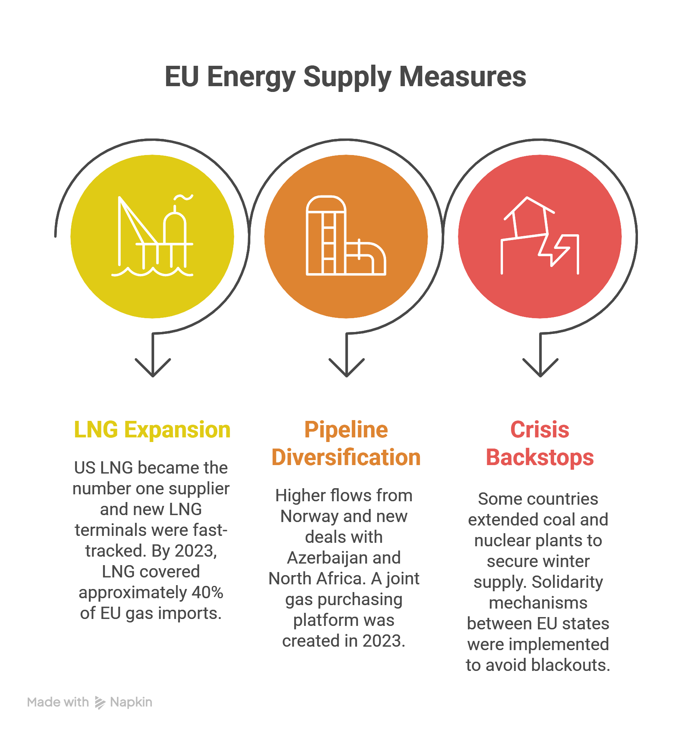

*Fig 2.1 showing: EU Energy Supply Measures*

## **2.2 The REPowerEU Plan**

### **2.2.1 Origins and Objectives**

Launched by the European Commission in May 2022, the REPowerEU plan represented the most comprehensive strategic framework for phasing out dependence on Russian fossil fuels. Its central objective was to eliminate Russian gas imports by 2027, while simultaneously accelerating the Union’s broader energy transition.¹ Unlike the ad hoc emergency measures of early 2022, REPowerEU signaled a longer-term policy commitment, reframing the crisis as an opportunity for structural change.

### **2.2.2 Three Pillars of Action**

The plan rested on three core pillars: saving energy, diversifying supplies, and producing clean energy.²[5]

1. **Saving energy**: Efficiency measures were prioritized, including building renovations, deployment of smart appliances, and incentives for reduced household and industrial consumption.
2. **Diversifying supplies**: Beyond LNG and new pipelines, diversification extended to hydrogen imports and partnerships with countries in the Middle East and North Africa.
3. **Producing clean energy**: The plan proposed accelerating investments in renewable energy (solar, wind, and green hydrogen) as a way to strengthen both decarbonization and energy independence.

### **2.2.3 Policy Sequencing**

A two-phase approach structured REPowerEU’s implementation. First, no new gas contracts with Russian suppliers were to be signed after 2025. Second, all remaining imports from Russia were to be phased out by 2027.³ This sequencing provided both political signaling and a policy roadmap for member states, aligning short-term emergency actions with long-term structural reforms.

### **2.2.4 Financing and Institutional Role**

The financing of REPowerEU relied on reallocating €225 billion in loans and €72 billion in grants from the Recovery and Resilience Facility (RRF).⁴ The Commission’s use of existing fiscal tools demonstrated its capacity to adapt instruments originally designed for pandemic recovery to a new crisis. However, debates emerged over the adequacy of funding and the balance between grants and loans, reflecting broader tensions in EU fiscal governance.

### **2.2.5 Strategic Implications**

REPowerEU was more than a technical policy framework; it marked a political shift in EU energy governance. By embedding energy security within the Green Deal, the Commission linked decarbonization with strategic autonomy. This linkage had both benefits and risks. On the one hand, it strengthened the case for rapid renewable deployment as a matter of security. On the other, it heightened concerns about the EU’s dependence on external supply chains, especially for solar photovoltaics and battery components sourced from Asia.⁵

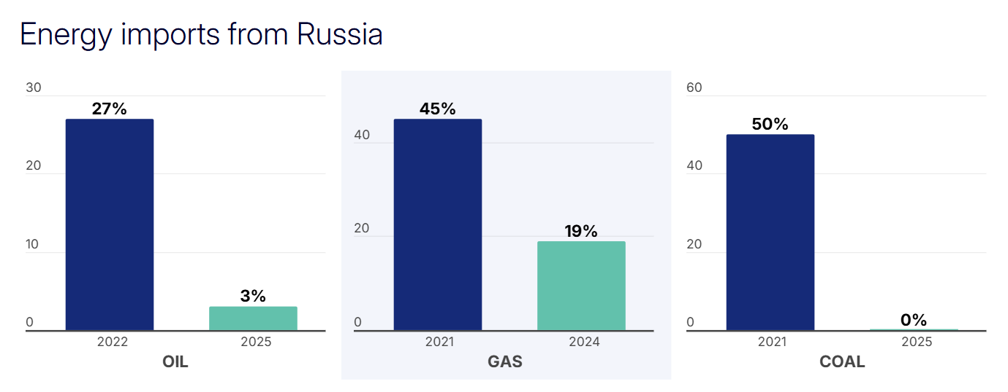*Fig 2.2 Showing: Decline of Russian gas imports under REPowerEU, 2022–2025*

*Source: (*[*https://commission.europa.eu/topics/energy/repowereu_en*](https://commission.europa.eu/topics/energy/repowereu_en)*)*

### **2.3 Gas Storage as Strategic Insurance**

Complementing demand reduction was the introduction of mandatory storage targets. In 2021, storage facilities were only about 50 percent filled heading into winter, leaving the EU vulnerable. By 2022, new regulation mandated an 80 percent fill rate, with member states ultimately achieving 95 percent. In 2023, the target was raised to 90 percent and successfully met.² These measures created what policymakers called a “collective insurance policy,” ensuring sufficient reserves across the Union.

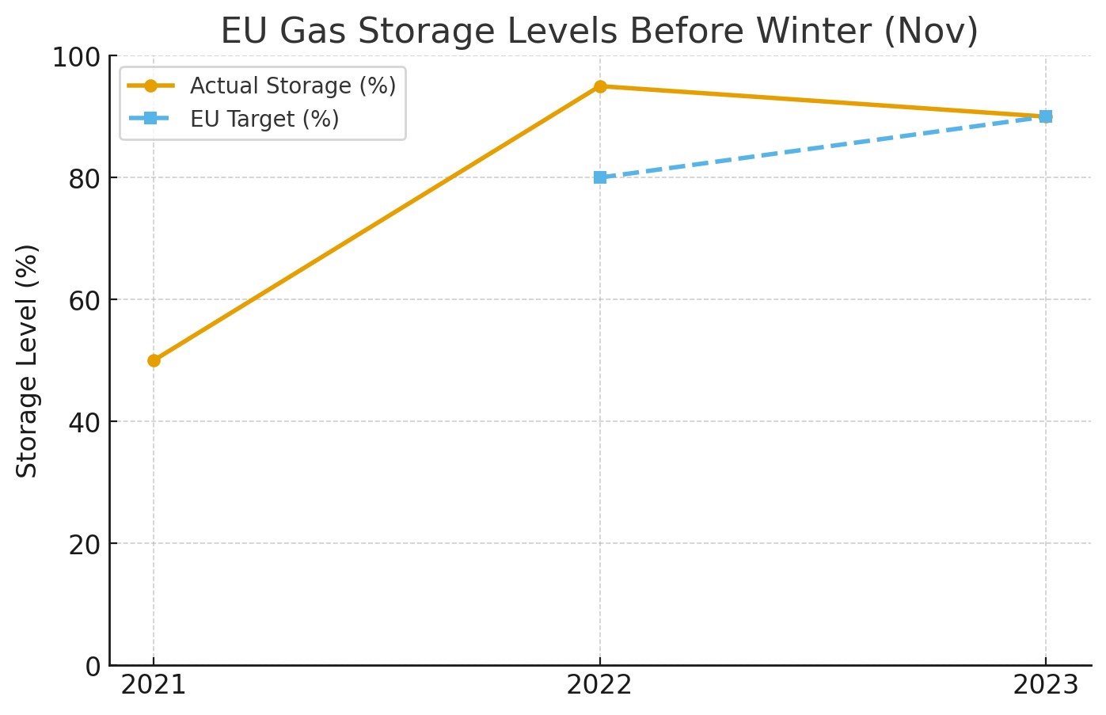

*Fig 2.3 Showing: EU gas storage targets vs. actual fill rates, 2021–2023*

## **2.4 The 15 Percent Reduction Target**

One of the most immediate tools adopted by the European Union was the regulation requiring member states to reduce natural gas demand by 15 percent in the winter of 2022–23.¹ This collective target was designed to ensure that storage reserves could last through the winter without Russian supply. Although legally binding only in cases of severe shortage, the political effect of the regulation was to establish solidarity and common purpose.

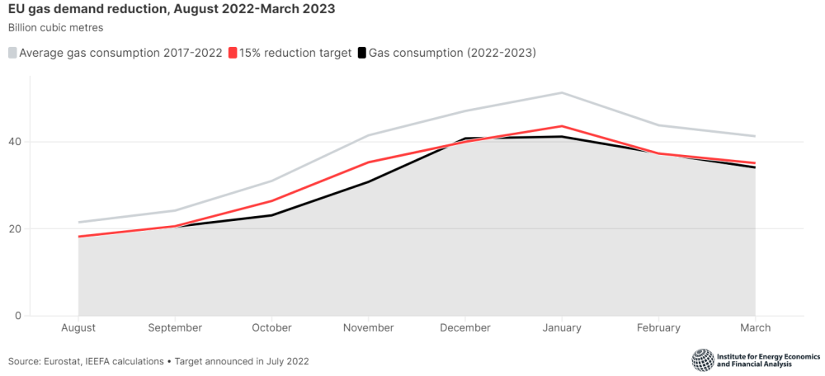

*Fig 2.4 Showing: EU natural gas consumption reduction, 2021–2023 (monthly % change)*

### **3. Trade Offs in Energy Policy & The Decarbonization Debate**

The European energy crisis of 2021–2023 revealed modern economies' vulnerability to sudden supply disruptions and geopolitical shifts. Primarily triggered by the Russian invasion of Ukraine and the subsequent collapse of trust in Russian fossil fuel exports, European countries faced an unprecedented challenge: balancing immediate energy security with longer-term sustainability and decarbonization goals. This moment forced governments, industries, and households to make difficult choices, revealing trade-offs between short-term security and long-term transformation.

This section examines the trade-offs faced during the crisis, with attention to what was sacrificed, risked, or delayed in pursuit of energy stability. It then explores the debate over whether the crisis represented a short-term setback for climate action or a medium-to-long-term accelerator of the green transition.

### **3.1 Trade-Offs in Energy Policy**

One of the clearest trade-offs was the effort to reduce dependence on Russian energy. For decades, Europe relied heavily on Russian natural gas and oil, a dependence that left many economies exposed when geopolitical tensions escalated. The decision to reduce and ultimately eliminate Russian imports came with significant sacrifices. In the short term, countries faced risks of stockouts and price spikes. Infrastructure was not equipped to fully handle alternative sources, forcing Europe to scramble for liquefied natural gas imports, build new terminals, and reconfigure pipelines (IEA, 2022)[6]. The scramble exposed the structural weakness of energy dependency. While reducing Russian leverage was necessary for geopolitical independence, the cost was steep: governments faced soaring expenditures, industries endured volatile prices, and households bore the brunt of rising energy bills. Vulnerable nations in Eastern Europe, which relied more heavily on Russian gas, were especially exposed.

The crisis also pushed the green transition higher on the policy agenda, though in a way that revealed paradoxes. On one hand, policymakers framed renewable energy and efficiency as tools of energy security. On the other hand, short-term energy needs forced a return to high-emission solutions such as coal-fired power. In several countries, mothballed coal plants were restarted, and investments in LNG infrastructure raised concerns about fossil fuel lock-in. Another trade-off came from supply chains. While solar panels, wind turbines, and battery storage offer long-term stability, their components are often sourced from non-European suppliers. Heavy reliance on imports from countries like China introduced new vulnerabilities, even as Europe tried to reduce dependence on Russia. Thus, while the green transition was accelerated rhetorically and strategically, the short-term path was far from linear.

Skyrocketing energy prices in 2022 added further complications. These price signals sent strong incentives to consumers and industries to conserve energy. The effects were visible in reduced demand and accelerated efficiency upgrades, but the benefits came with harsh social costs. Households, particularly low-income families, faced unaffordable electricity and heating bills, often described as energy poverty (IMF, 2022)[7]. Industries faced shrinking profit margins or shutdowns, creating ripple effects throughout national economies. Governments attempted to cushion the impact with subsidies and price caps, but these came at a fiscal cost. In balancing conservation incentives with social protections, policymakers had to navigate a difficult tension between market efficiency and social equity.

In building resilience, Europe invested heavily in new LNG terminals, gas storage, and alternative pipeline routes. While these investments provided immediate security, they carried long-term risks. If demand for fossil fuels declines more quickly than expected due to decarbonization, some of these assets may become stranded, yielding little return on investment. The emergency expansion of infrastructure was, therefore, both a success in the short-term and a gamble for the future. Policymakers now face the challenge of avoiding over-investment in fossil-based systems while ensuring sufficient backup capacity for emergencies.

The geopolitical dimension of these trade-offs cannot be overlooked. By imposing sanctions on Russia and reducing fossil fuel imports, Europe reclaimed some degree of geopolitical independence. However, this shift had ripple effects across the global energy market. Retaliatory measures, volatility, and price spikes disproportionately affected developing economies, which lacked the fiscal capacity to shield their populations from higher energy costs. The European strategy, while necessary for regional security, thus highlighted global inequities. Energy-hungry countries outside of Europe, particularly in Asia and Africa, faced greater instability, underscoring the interconnected nature of international markets.

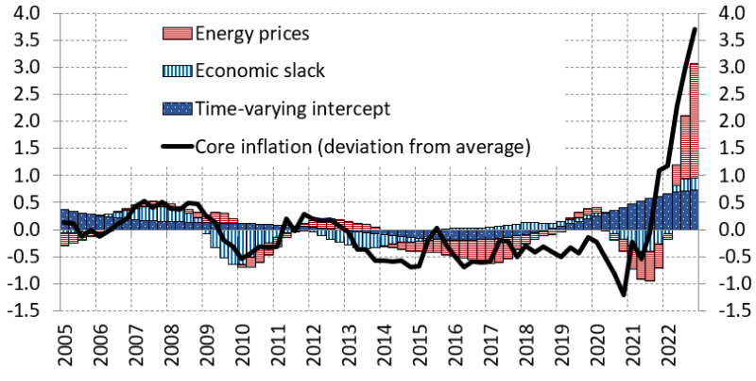

*Fig 3.1 Showing: Increase in Inflation due to Energy Prices in EU countries*

Finally, the crisis forced Europe to grapple with the relationship between economic growth and stability. Rising prices fueled inflation, reducing real incomes and straining household budgets. Governments faced fiscal burdens as they attempted to subsidize energy bills, risking long-term debt accumulation. The risk of stagflation became real in several European economies. At the same time, debates intensified around whether prioritizing immediate stability undermined long-term decarbonization, particularly as governments diverted attention to managing inflationary pressures.

### **3.2 Decarbonization Debate**

The crisis sparked debate over whether Europe’s decarbonization trajectory suffered setbacks or gained momentum. In the short term, there were apparent setbacks. Restarting coal and oil plants drove temporary increases in emissions. Heavy investment in LNG infrastructure raised the risk of fossil fuel lock-in. Policy focus on immediate energy security frequently overshadowed climate goals in 2022 and 2023.

At the same time, however, the crisis created new conditions for acceleration. Renewables and efficiency were reframed as matters of national security rather than just environmental responsibility. This shift in perspective generated political momentum for large-scale investment in clean energy. The European Union launched its REPowerEU plan, emphasizing energy independence through renewables (European Commission, 2022)[8]. At the same time, across the Atlantic, the United States passed the Inflation Reduction Act, which further encouraged global green investment.

In addition to policy measures, societal behavior also shifted. The experience of high energy prices encouraged households and businesses to adopt conservation strategies that may persist in the long term. Demand reduction and efficiency improvements, motivated by necessity, could impact energy consumption patterns. In this sense, the crisis was both a short-term setback and a long-term catalyst. Europe temporarily increased its carbon footprint to keep the lights on, but simultaneously laid the groundwork for a faster fossil fuel exit.

The European energy crisis forced policymakers to confront unavoidable trade-offs. Reduced dependence on Russia improved geopolitical security but imposed immediate financial and social costs. Efforts to accelerate the green transition created paradoxes, with temporary reliance on coal and LNG investments. Price signals improved efficiency but exacerbated inequality, while infrastructure investments secured supply at the risk of future obsolescence.

Ultimately, the crisis revealed that short-term sacrifices are sometimes necessary to achieve long-term resilience. Europe’s experience illustrates that energy transitions are rarely linear. The shock of 2021–2023 created temporary carbon backsliding, but it also reframed renewables, efficiency, and diversification as cornerstones of security. Suppose policymakers can balance social protections with long-term sustainability. In that case, the crisis may be remembered not as a failure, but as a turning point in Europe’s path toward a low-carbon future.

**4. Critical Analysis and Conclusion: Climate Policy and the Global Energy Transition**

**4.1 Introduction**

The Ukraine war and its associated energy shock have reshaped discussions on global energy systems, environmental policy, and the pace of climate change mitigation. While much of the immediate debate has centered on how Europe diversified away from Russian fossil fuels, the crisis also illuminates deeper structural challenges in the global energy transition. This report offers a critical analysis of contemporary climate and energy policy and concludes with reflections on lessons learned and pathways forward. The analysis situates the Ukraine war within the broader dynamics of climate governance, examining the strengths and weaknesses of existing frameworks and outlining the key trade-offs policymakers must navigate.

**4.2 Critical Perspective on Policy Strengths**

One clear strength of recent years has been the strengthening of international climate governance. The Paris Agreement established a global framework for collective action, and subsequent meetings such as COP28 in Dubai moved beyond pledges toward implementation (UNDP, 2023). At COP28, countries reached a historic agreement to “transition away from fossil fuels,” a rhetorical and symbolic step that strengthens normative pressure on governments and corporations.

The European Union has emerged as a leader in climate policy. Through the European Green Deal, the EU committed to achieving net-zero emissions by 2050, cutting emissions 55% by 2030 compared to 1990 levels, and investing in circular economy strategies (European Commission, 2022). The deal is backed by strong monitoring institutions, such as the European Environment Agency, which provides real-time environmental data to ensure accountability.

In the United States, the Inflation Reduction Act of 2022 represents the largest climate investment in American history. It provides subsidies for renewable energy, incentives for electric vehicles, and funding for decarbonizing heavy industries. The act is expected to significantly accelerate clean energy adoption, positioning the U.S. more competitively in the global energy transition (IEA, 2021).

These initiatives demonstrate that ambitious policy frameworks exist and that climate governance has advanced substantially compared to a decade ago.

**4.3 Key Weaknesses and Limitations**

Despite these strengths, several weaknesses undermine global climate action. First, international efforts remain uneven. There is a persistent divide between developed and developing countries, particularly regarding climate finance. The “loss and damage” fund agreed at COP28 represents progress, but its operationalization remains limited (UNDP, 2023). Developing countries continue to argue that without sufficient financial support, they cannot transition away from fossil fuels while still meeting urgent human development needs.

Second, many policy frameworks rely heavily on technological fixes that remain uncertain. Carbon Capture, Utilization, and Storage (CCUS) has been promoted as a critical solution for decarbonizing hard-to-abate sectors such as steel and cement (IEA, 2021). However, the technology remains expensive, energy-intensive, and geographically constrained. Overreliance on CCUS risks delaying more structural changes, such as phasing out fossil fuel infrastructure.

Third, short-term energy crises expose the fragility of climate commitments. The Ukraine war forced the European Union to increase coal consumption and expand imports of liquefied natural gas, temporarily raising emissions (Wendling et al., 2022). This demonstrates that even ambitious regions like the EU must balance climate goals against immediate security needs. Without strategies that integrate resilience into climate planning, progress can be easily disrupted.

**4.4 Critical Trade-Offs**

These strengths and weaknesses highlight the enduring trade-offs of climate and energy policy.

Decarbonization vs. Energy Security: Policymakers must accelerate decarbonization to avoid catastrophic warming, but they cannot ignore citizens’ need for affordable and reliable energy. The Ukraine war exemplifies how short-term energy shocks can derail long-term transition efforts (Wendling et al., 2022).

Market Innovation vs. Equity: Market-driven innovation has spurred rapid renewable deployment, but it does not guarantee equitable access. Many communities, particularly in the Global South, risk being excluded from clean energy transitions unless stronger redistributive mechanisms are in place (UNDP, 2023).

Technological Optimism vs. Structural Change: Technologies like CCUS and hydrogen offer promise, but cannot substitute for structural reforms in energy systems and consumption patterns. Policymakers must avoid the temptation of deferring systemic change in favor of uncertain technological fixes (IEA, 2021).

Understanding and managing these trade-offs is crucial to sustaining climate progress.

**4.5 Lessons from the Ukraine War**

The Ukraine war functions as a stress test for the global energy transition. In Europe, the crisis highlighted vulnerabilities created by overdependence on Russian gas. Policymakers were forced to respond with short-term emergency measures, including increased LNG imports and a temporary return to coal. Yet paradoxically, the crisis also accelerated structural reforms. The REPowerEU plan boosted renewable energy investments, infrastructure for hydrogen, and diversification of supply chains (European Commission, 2022). Thus, the Ukraine case illustrates both the risks and opportunities of crisis-driven policymaking.

For the United States, the war created an opportunity to expand liquefied natural gas exports, strengthening its geopolitical role in energy markets. Yet this also raised questions about whether U.S. fossil fuel expansion undermines global decarbonization commitments (UNDP, 2023). Meanwhile, China leveraged discounted Russian fossil fuels but simultaneously doubled down on renewables and critical minerals, underscoring its dual strategy of short-term opportunism and long-term transition leadership (UNDP, 2023).

The broader lesson is that geopolitical shocks will remain an inevitable feature of global energy politics. Effective climate policy must be resilient to such shocks, ensuring that progress toward net-zero does not collapse under external pressure (Wendling et al., 2022).

**4.6 Path Forward and Future Outlook**

Looking ahead, several developments will shape the trajectory of global climate and energy policy. COP29 in Baku will focus heavily on climate finance, particularly the creation of a new collective quantified goal to support developing countries. COP30 in Brazil will center on enhanced nationally determined contributions aligned with the 1.5°C target (UNDP, 2023). These meetings will test the ability of the international community to move from symbolic alignment to concrete action.

At the same time, clean energy investment continues to surge. Global spending on renewables exceeded $1.7 trillion in 2024 and is projected to surpass $2 trillion in 2025 (IEA, 2021). Employment in renewables now outpaces fossil fuels, illustrating a structural labor shift. These trends show that market momentum is increasingly aligned with decarbonization, but political and social challenges remain.

Finally, collaboration among the United States, the European Union, and China will be critical. Together, these actors account for the majority of global emissions, technology development, and financial resources. Without coordinated leadership, global progress will remain fragmented (Wendling et al., 2022).

**4.7 Conclusion**

In conclusion, the Ukraine war underscored the fragility of global energy systems and the difficulty of aligning short-term energy security with long-term climate goals. Climate governance has strengthened significantly, with ambitious initiatives such as the EU Green Deal and the U.S. Inflation Reduction Act. Yet persistent weaknesses—including uneven commitments, overreliance on uncertain technologies, and vulnerability to geopolitical shocks—limit progress.

The critical takeaway is that sustainable development requires balancing today’s human needs with tomorrow’s planetary limits. Policymakers must design resilient strategies that integrate equity, institutional strength, and resilience to crisis. Only by managing these trade-offs can the international community achieve the dual goals of human development and planetary sustainability (UNDP, 2020; Wendling et al., 2022).

**References**

1. Ag, Nord Stream. n.d. “The Pipeline - Nord Stream AG.” Nord Stream AG. <https://www.nord-stream.com/the-project/pipeline/>.
2. Di Bella, Gabriel, Mark Flanagan, Karim Foda, Svitlana Maslova, Alex Pienkowski, Martin Stuermer, and Frederik Toscani. 2024. “Natural Gas in Europe: The Potential Impact of Disruptions to Supply.” *Energy Economics*138 (July): 107777. <https://doi.org/10.1016/j.eneco.2024.107777>.
3. European Commission. (2022). Carbon Border Adjustment Mechanism (CBAM). <https://climate.ec.europa.eu/eu-action/eu-emissions-trading-system-eu-ets/carbon-border-adjustment-mechanism_en>
4. European Commission. (2022). *REPowerEU plan.* <https://ec.europa.eu/commission/presscorner/detail/en/IP_22_3131>
5. International Energy Agency. (2022). *Europe’s scramble for LNG and gas security.* Paris: IEA.
6. International Monetary Fund. (2022). *Coping with energy price shocks in Europe.* Washington, DC: IMF.
7. International Energy Agency (IEA). (2021). World Energy Outlook 2021. https://iea.blob.core.windows.net/assets/4ed140c1-c3f3-4fd9-acae-789a4e14a23c/WorldEnergyOutlook2021.pdf
8. “Russia’s Gas Transit Through Ukraine: End of an Era?” 2025. Wilson Center. February 4, 2025. <https://www.wilsoncenter.org/blog-post/russias-gas-transit-through-ukraine-end-era>.
9. Sterling, Julianna, Missaka Warusawitharana, and Xiangyu Zhang. 2025. “European Energy Import Dependency.” April 16, 2025.

<https://www.federalreserve.gov/econres/notes/feds-notes/european-energy-import-dependency-20250416.html#:~:text=Historical%20Trends,dependency%20ratio%20of%2058.3%20percent>.

1. U.S. Department of Energy and U.S. Energy Information Administration. 2025. “Country Analysis Brief: Ukraine.” *U.S. Energy Information Administration*. <https://www.eia.gov/international/content/analysis/countries_short/Ukraine/Ukraine.pdf>.
2. Wendling, Z. A., Emerson, J. W., Esty, D. C., Levy, M. A., & de Sherbinin, A. (2022). 2022 Environmental Performance Index. Yale Center for Environmental Law & Policy. <https://epi.yale.edu/>

1. *Decarbonization aims to lower the amount of CO2 emitted from anthropogenic activity, with the ultimate goal of eliminating all human-made CO2 emissions in their entirety.* 
2. *Image notes: Thicker and darker lines represent larger transmission capacities as of December 2021. Direction of flows within EU and individual pipelines not shown. Dotted lines represent import pipelines into Europe. Dashed yellow lines represent pipelines expected to come online in the next twelve months.*
3. *The EU's overall trend has been of increased energy import dependency except some fluctuations during the pandemic. In 2022, the dependency ratio reached its highest point over the sample period (1990 to 2024) of 62.5 percent, consistent with Eurostat (2024) (Sterling, Warusawitharana, and Zhang 2025).*
4. International Energy Agency, *Europe’s Energy Crisis: Security, Solidarity and the Role of LNG* (Paris: IEA, 2022).  
   ²European Commission, *Joint European Gas Purchasing and Collective Energy Security Mechanisms under REPowerEU* (Brussels: European Commission, 2022).  
   
5.
6. International Energy Agency. (2022). *Europe’s scramble for LNG and gas security.* Paris: IEA.
7. International Monetary Fund. (2022). *Coping with energy price shocks in Europe.* Washington, DC: IMF.
8. European Commission. (2022). *REPowerEU plan.* 